Social Media Tool Kit

The third annual IU Day, April 18, is so on...On campus. And definitely on social media.
To make Lilly Family School of Philanthropy’s IU Day crowdfunding campaign the most far-reaching and philanthropic yet, we’ve provided some social media posts and graphics for you to share with your followers. Make sure to tag us so that we can retweet, repost, and say thanks!
@IUPhilanthropy

/IULillyFamilySchool ofPhilanthropy

Sample Posts (can also be used on sticky notes…)
Mark your calendar. #IUDay is April 18. @IUPhilanthropy & me + you = fantastic and philanthropic. http://bit.ly/LFSOPIUDay
Philanthropy - voluntary action for the public good – is something we all do. Support @IUPhilanthropy today and be philanthropic! #IUDay http://bit.ly/LFSOPIUDay
Together, we can create a stronger, more charitable society and a better world for all. @IUPhilanthropy #IUDay http://bit.ly/LFSOPIUDay
Happy 30th Anniversary @IUPhilanthropy! And happy #IUDay! So many reasons to celebrate today. http://bit.ly/LFSOPIUDay
Shout out to all my friends who support @IUPhilanthropy on #IUDay - let’s get philanthropic! http://bit.ly/LFSOPIUDay
Celebrating a great American tradition today – philanthropy – and supporting @IUPhilanthropy on #IUDay. Will you join me? http://bit.ly/LFSOPIUDay
How does your giving and volunteering compare to people like you? Take a six-question @IUPhilanthropy survey to find out! (Giveometer URL). Then to increase your percentile, make a gift on #IUDay http://bit.ly/LFSOPIUDay
It’s @IUPhilanthropy’s 30th Anniversary…and #IUDay! To celebrate, join me and make a gift of $30 or more to @IUPhilanthropy today! http://bit.ly/LFSOPIUDay

DOWNLOADS

Facebook Cover graphic
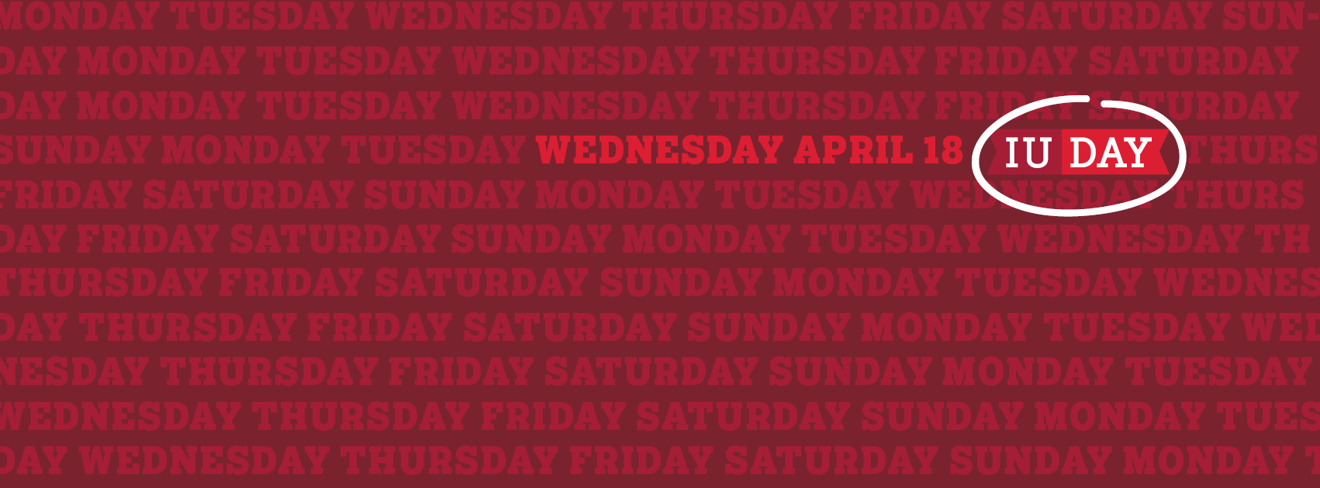
Twitter Cover graphic

Rectangle Graphics

